Brief

Students had to use handheld air quality monitors to collect their own measurements for air pollution parameters e.g., PM_{2.5}, PM₁₀ and so on either at two different street locations, or from the same street but at different time points on that same street, in London.

They are tasked with answering the main research question:

Are there any significant difference in the mean air quality indicator measured between the two streets you were designated with?

Alternatively, if you remained on the same street and collected data at two different time points. Are there any significant difference in the mean air quality indicator measured between the before and after time points on streets you were designated with?

They had to answer these questions:

- They need to perform a descriptive analysis comparing the mean and standard deviation between the groups.

- Produce a visual of a dual boxplot to show the comparison.

- Perform the appropriate t-test (paired/unpaired).

Important note about T-test:

There are two scenarios to they had to consider, which depended entirely on how they collected their dataset:

Scenario 1:
If they used the handheld device to collect air-quality measurements at Street A, and then moved to a different site, say Street B, to collect more measurements, the two sites are independent of each other. In this case, they should use an unpaired t-test to assess whether the air-quality measurements at these streets were the same or significantly different.

Scenario 2:
Suppose they used the handheld device to collect repeated air-quality measurements from Street A, say on a Monday, and then returned to the same Street A on a Tuesday to collect more measurements. Because they remained at the same street but collected information at different time points, this becomes a before-and-after situation, and the samples are dependent. In this case, they should use a paired t-test to assess whether the before-and-after measurements differ.

So, the data entry for analysis for the two scenario would broadly be to create two separate objects (as groups) for entering measurements:

[Scenario 1]

Street_A <- c(23.8, 25.6, ...)
Street_B <- c(21.6, 20.5, ...)

OR

[Scenario 2]

Before <- c(23.8, 25.6, ...)
After <- c(21.6, 20.5, ...)

These objects should then be passed into the t.test() function and declared within the function as paired = TRUE for Scenario 2, or paired = FALSE for Scenario 1.

[Scenario 1: Unpaired]
t.test(Street_A, Street_B, paired = FALSE)

[Scenario 2: Paired]
t.test(Before, After, paired = TRUE)

Solutions

Question 1

Students are expected to perform descriptive analysis of their air pollution data. Therefore, students are supposed compute the mean and standard deviation of the selected air quality parameter and compare the magnitudes of the differences between street locations (or time points). They can describe which location or time point shows higher or lower mean levels of the selected air contaminant relative to the other.

In addition, they can need to comment, at face value, on whether there is truly a difference by using the standard deviation i.e., taking ±1 SD around the mean for each group and checking whether the ranges overlap. If there is an overlap, it suggests that the groups (i.e., street locations, or time point depending on the scenario) could potentially be the same; if there is no overlap, they could potentially differ.

Look for these kinds of interpretations in the descriptive section for Question 1.

An example of correct answer for this question is shown in this screenshot:

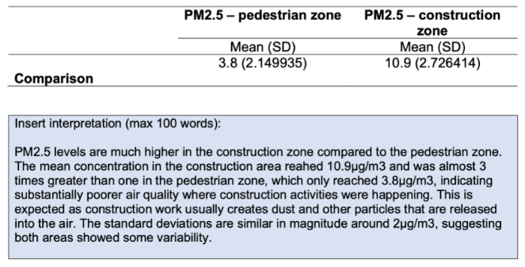

Question 2

Students are required to produce a dual boxplot, meaning both boxplots to be shown in the same panel sharing the same y-axis to allow proper comparison. If the boxplots are in separate panels – this is a critical error. The visualisation should reinforce the interpretation provided in Question 1.

Again, students should compare the magnitudes and describe the distribution of the data in each group. They can comment on how the median in one group is higher or lower than in the other, as well as the interquartile ranges, overall spread, and extreme values (minimum and maximum). They should also note whether the ranges overlap, as this provides a descriptive indication of how similar or different the groups might be.

Here is an example correct answer for dual boxplot output:

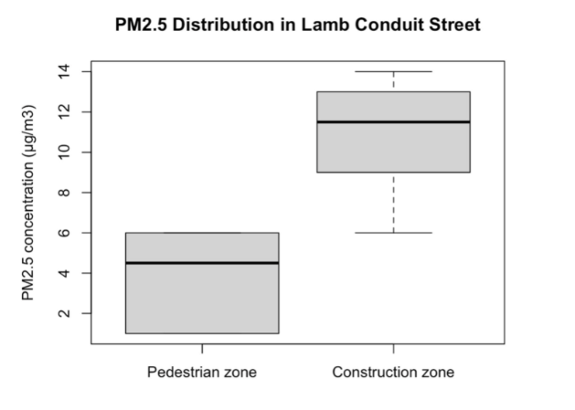

A couple of things to note – the boxplot should look like this image with (1.) full annotation on the y- and x-axis, (2.) with each box carrying its label about the bottom and (3.) a main title at the top.

The expected interpretation of the plots should look something as follows:

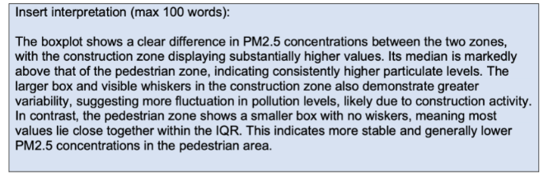

Question 3

Depending on how the data set was collected. It branches the analysis into two scenarios – which will result in using either an unpaired t-test, or paired t-test (see brief).

Explanation: If students used an unpaired t-test (alternatively called Welch), they must explicitly explain that the air quality samples were collected from two different streets, meaning the measurements are independent. If they use a paired t-test, they must clearly state that the samples were collected at two different time points at the same location, meaning the measurements are dependent.

This explanation may also have been provided somewhere in Questions 1 or 2. With that said, this is what to look for in their interpretation:

Scenario A: Unpaired t-test

If the result is significant, they need to say in the interpretation the following points:
- There is strong evidence that the mean level of the selected air contaminant differs between the two streets.
- This conclusion is based on the p-value being less than 0.05.
- Therefore, we reject the null hypothesis, which states that the air quality means between the two streets are equal, and conclude that the means are different.

But, if the result is not significant, students should state that the evidence is insufficient to conclude that the means differ between the two-street location. The p-value is greater than 0.05, accepting the null hypothesis which states that the air quality means between the two streets are equal.

Here is an example of good interpretation with unpaired t-test:

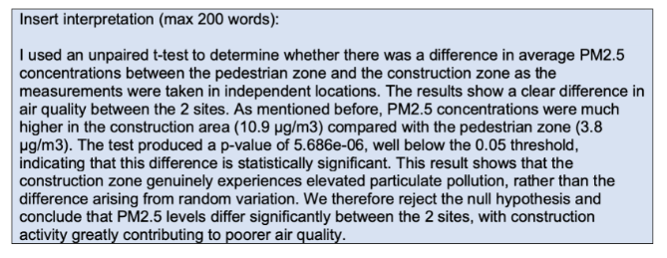

Scenario B: Paired t-test

If the result is significant, they should say that:
- there is strong evidence that the mean level of the selected air contaminant differs before and after measurement at the same street (i.e., across the two time points).
- This conclusion is supported by the p-value being less than 0.05
- we reject the null hypothesis, which states that the air quality mean between the two time points is the same, and conclude that the means are in fact different.

If the result is not significant, again, students should state that the evidence is insufficient to conclude a difference between the two time points on the same street. The p-value is greater than 0.05, so we fail to reject the null hypothesis.

Note – it should be similar but distinction in scenario B is the use of paired t-test mentioning of before-and-after effect on same street segment.

